**MINISTRY OF JUSTICE**

**Ministry of Justice**

MOJ Web & Mobile Application

Submitted By:

VERBANET TECHNOLOGIES L.L.C

**CONTENTS**

0 KEY DETAILS 6

1 EXECUTIVE SUMMARY 7

2 STATEMENT OF WORK 8

2.1 SCOPE 8

2.2 CONCEPT AND DESIGN ITERATIONS 12

2.3 TRAINING OF WEB ADMINS AND CMS USERS 14

2.4 BUILD AND TEST 14

Meanwhile, in every step, if there is an error, am email is relayed to the development team so that they can fix it. Then they will push it into the version control system and it goes back into the pipeline. 18

Once again, if there is any error reported during testing, the feedback goes to the dev team again, where they fix it and the process reiterates if required. 18

This lifecycle continues until the code/a product can be measured and validated. 18

To automate the entire process, i.e. from development to production Verbat makes use of automation tools. 19

Verbat makes use of Jenkins which provides various interfaces and tools that automate the entire process. 19

Git repository is where the development team will commit the code. Jenkins takes over from there. It has a front-end tool that allows you to define the entire job or the task and ensures the continuous integration and delivery process. 19

From Git, Jenkins pulls the code and then Jenkins moves it into the commit phase, where the code is committed from every branch. The build phase is where code compilation happens. If it is Java code, tools like maven compile the code, which can be deployed to run a series of tests. These test cases are overseen by Jenkins again. 19

Then, it moves on to the staging server to deploy it using Docker. After a series of unit tests or sanity tests, it moves on to production. 19

20

As mentioned before unit testing is one type of testing conducted. Aside from Unit testing,Verbat also makes use of tests based on 20

**Behaviour Driven Development (BDD)** 20

BDD encourages communication between project stakeholders so all members understand each feature, prior to the development process. In BDD, testers, developers, and business analysts create “scenarios”, which facilitate example-focused communication. 20

The idea of BDD is that the team creates scenarios, builds tests around those scenarios which initially fail, and then builds the software functionality that makes the scenarios pass. It is different from traditional Test Driven Development (TDD) in that complete software functionality is tested, not just individual components. 20

21

**Acceptance Test Driven Development (ATDD)** 21

ATDD involves the customer, developer, and tester. “Three Amigos” meetings are held to gather input from these three roles, and use them to define acceptance tests. The customer focuses on the problem, the developer pays attention to how the problem will be solved, and the tester looks at what could go wrong. 21

The acceptance tests represent a user’s perspective, and specify how the system will function. They also ensure that the system functions as intended. Acceptance tests can often be automated. Like in the BDD approach, acceptance tests are written first, they initially fail, and then software functionality is built around the tests until they pass. 21

22

**Exploratory Testing** 22

In exploratory testing, the test execution and the test design phase go together. This type of testing focuses on interacting with working software rather than separately planning, building and running tests. 22

Exploratory testing lets testers “play with” the software in a chaotic way. Exploratory testing is not scripted – testers mimic possible user behaviors and get creative, trying to find actions or edge cases that will break the software. Testers do not document the exact process in which they tested the software, but when they find a defect, they document it as usual. 22

23

2.5 ON-GOING SUPPORT 24

2.6 LIST OF DELIVERABLES 25

2.7 TIME SCALE FOR PHASES (WITH ASSUMPTIONS) 26

2.8 ACCEPTANCE CRITERIA 28

3 MOJ RESOURCE ASSUMPTIONS AND RESPONSIBILITIES 28

4 INFRASTRUCTURE DESIGN AND ARCHITECTURE 30

4.1 Deployment Options 31

4.2 Technology Architecture 31

4.3 Server Architecture 32

5 QUALITY PLAN 33

5.1 Communication 33

5.2 Content management 33

5.3 Website Functionality 34

6 WARRANTY OF SOLUTION 36

7 FACILITIES REQUIREMENT 36

8 NAMED RESOURCES FROM VENDOR 36

9 PROJECT MANAGEMENT METHODOLOGY 37

10 FINANCIALS 38

10.1 COSTS 38

10.2 PAYMENT MILESTONES 38

11 VENDOR PROFILE 39

12 NON-FUNCTIONAL REQUIREMENT (OTHERS) 41

13 OUT OF SCOPE. 42

13.1 CHANGE MANAGEMENT 43

13.2 MAINTENANCE & SUPPORT 44

13.3 SERVICE LEVEL AGREEMENT (SLA) 44

14 TERMS & CONDITIONS. 46

14.1 WARRANTY 46

14.2 SOURCE CODE & INTELLECTUAL PROPERTY RIGHTS 46

14.3 GENERAL TERMS AND CONDITIONS 46

14.4 GENERAL ADMINISTRATIVE, TECHNICAL & FUNCTIONAL ASSUMPTIONS 48

15 ABOUT US. 49

# KEY DETAILS

**PROJECT NAME CLIENT**

MOJ Web & Mobile Application Ministry of Justice

**CLIENT CONTACT CLIENT ADDRESS**

Mr. James Smith P.O.Box 123

James.smith@mbc.com ABC Street

+971 4 234 534 Dubai

U.A.E

**PROPOSAL SUBMISSION PROPOSAL ID NO.**

22.04.19  AD/BP/25042018/1820/2

**PROPOSAL VALID UNTIL ANTICIPATED START DATE**

22.04.19 00.00.00

**PROPOSAL SUBMITTED BY PROPOSED TECHNOLOGY**

Simi Thomas ASP.NET

Verbanet Technologies L.L.C

Dubai, U.A.E **APPLICATION TYPE**

+971 4 297 3236 Web & Mobile Application

+971 50 765 2345

simi.thomas@verbat.com

# EXECUTIVE SUMMARY

Ministry of Justice vision is to become a model in the achievement of justice by providing judicial services that ensure the rule of law and the protection of rights and liberties.

The vision is based on Ministry’s values which are realized through the goals MOJ has set out to achieve:

* Establish a culture of innovation in the workplace
* Ensure the provision of administrative services in accordance with standards of quality, efficiency and transparency
* Facilitate easy access to justice for all and support the partnership of the ministry on local and international dissipate legal knowledge
* Build modern penal system that helps to protect the security and personal rights
* Support specialized judiciary that is based on knowledge and ensures independence and improvement
* Contribute to law and legislation preparation to satisfy society’s needs

Ministry of Justice, (hereafter referred to as “Client”) has approached Verbanet Technologies L.L.C., (hereafter referred under its trade / brand name as” Verbat”) to develop a Ministry of Justice mobile and web application to be used by UAE citizens and residents.

# STATEMENT OF WORK

## SCOPE

Ministry of Justice is looking to replace the current website. Its aim is to

* Design and develop a new website based on the TRA guidelines and include more comprehensive features
* Be Innovative and user friendly website that shall engage the targeted audiences
* Offer its services to UAE citizens and residents through its mobile application (Android & iOS) using the latest trends with enhanced functionalities to provide better UX and UI to their clients

### FUNCTIONAL SCOPE

#### General Requirements

The general requirements are:

* The website should be creatively designed
* Shall be easy to navigate; provide rich content in an interesting and interactive way
* Represent the MOJ brand; incorporate designs that inspires confidence in MOJ to deliver on its objectives
* It shall follow TRA guidelines
* Vendor shall have experience working with federal government websites and provide references of government websites which have 95% score on TRA evaluation
* Website shall follow innovational KPI’s 5 & 6
* Content shall be delivered in Arabic and English
* Shall be compatible with the latest versions of all major browsers
* Training the MOJ team on how to use the software

#### WEB APPLICATION

**KEY MODULES**

* Service Directory
* Laws and regulations sub-site
* E-services
* News highlights
* Events calendar
* Photo & video gallery
* Open data
* Survey & Polls
* Careers Module
* Complaints & suggestions
* Social media Integration
* Advanced search
* FAQ’s
* Social media hub
* Campaigns
* Media Kit
* Accessibility options
* Google Analytics
* SEO friendly features
* Contact us

**KEY REQUIREMENTS**

* Content Management System
  + Personalized content for different user groups and content suggestions
  + Unlimited structure: add unlimited contents such as pages, news, galleries, Publications, etc.
  + Copy & paste content from word to editor
  + User roles with different permissions
  + Search facility
  + Insight reports: non-translated contents and missing reports
  + Image/document library: localized alt text, media gallery
  + Related items: associate articles
  + Innovative KPI’s
* Advanced search
  + Comprehensive search module
  + Key word search
  + Different type of contents
  + Date filter
  + Auto complete & suggestions
* Current website contents migration
* Integrate google auto translate & localize content in more than one language
* META descriptions: Unique & user friendly URL, short url for images and documents
* Integrate text to speech add-on
* Integration with happiness meter supported by PMO systems
* Integrate MOJ’s social media into main interface website
* Integrate with MOJ live chat service
* Surveys & Polls
  + Create & publish unlimited surveys and polls
  + Archive for previous surveys and polls
* Cross browser capability
* XML Site map in website root directory
* Accessibility features
  + Font size
  + Theme implementation according to color blindness guidelines
  + Night reading theme
  + Text to speech
  + 3 additional theme colors

#### MOBILE APPLICATION

* Informational pages
* News
* Events timeline
* Advance search
* Service search
* Contact us
* Get directions
* Locations across UAE
* Accessibility features
* Theming options
* Integration with native accessibility options
* Push notifications
* Integration with khadamati and happiness meter

### TECHNICAL SCOPE

* The website shall be Developed using CSS3 and HTML5
* Responsive web application
* Bi lingual website
* Mobile app shall support Andoid 5+ and IOS9.3+
* Cross browser compatibility. Web site shall be viewable on all major browsers
* It shall have accessibility features to increase font size, multiple reading modes including a night theme and a theme that supports color blindness
* Text to speech functionality

The guidelines provide instructions and conditions that will be adhered to during the development of the mobile application.

* API will be used, as the case may be, in realizing the features and functionalities mentioned
* The client will finalize the functional requirements and UI/UX before the commencement of the project
* Verbat will be testing the app in the mentioned devices only. Testing on devices other than the ones mentioned under the “Technical Standards “ will have to be specified and provided by the client at the beginning of the development phase
* The client will have to provide the details of the testing devices they are using before the start of development phase
* Client should provide the relevant Developer's Account credentials before the development phase. In case Verbat needs to create the developer id additional charges will be incurred by the client
* The duration mentioned in the project time line is for development and testing and any delay or time taken by the review team to respond will not be Verbat’s responsibility
* Any clarification required from client needs to be addressed within 24 hrs.
* The apps will be developed / created within the guidelines of Android play and Apple store.
* Verbat will strictly follow the guidelines provided by the respective stores.
* Verbat will inform the client if any of the client requirements / request deviates from it.
* Customization of the features of the app will be susceptible to the limitation imposed by the respective platform/ store.
* Once development commences the test device/screen sizes will not be susceptible to change. Any change requested by the client will have to go through change management

OS version support will be limited to the ones mentioned in the technical specifications. Further support will have to go through change management

## CONCEPT AND DESIGN ITERATIONS

Design iteration means learning from failure before putting a product in front of users – so

Conceptualizing and designing a product, whether it be a mobile application or a web based application is an iterative process. Verbat ‘s UI and UX designers derives inspiration from several sources before embarking on the design process.

Verbat recognizes that prototyping is relatively cheap to do (for example the lowest fidelity prototype might consist of nothing but pen and paper sketches) and relatively quick to create, it makes for a cost-effective system to improve designs without doing all the hard work (development) and then discovering that the difference between what users said they would do and what they actually do is large and expensive to overcome.

Prototyping through iterations are built naturally into our development workflow because our development process follows the agile methodology.

When our team is faced with several ideas and is unsure of which to pursue. Developing a prototype of each idea and then assembling rapid user feedback ensures that the best ideas are taken forward and those which do not provide as much benefit are abandoned with no investment in their development.

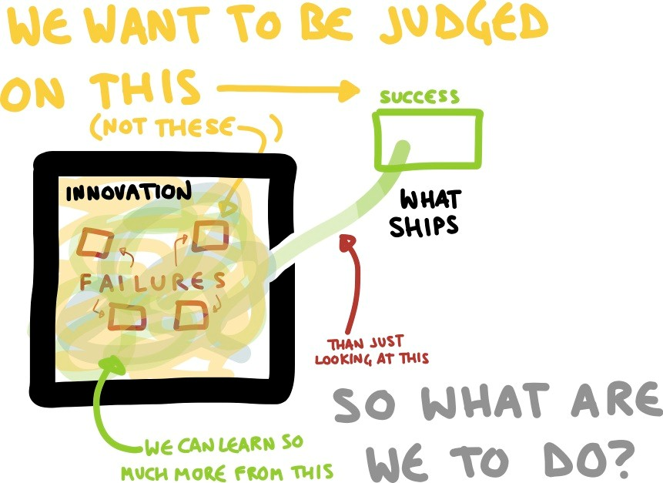

## TRAINING OF WEB ADMINS AND CMS USERS

Client will be provided with one time training (train the trainer) on how to use the application via video conference (maximum of 4 hours). Additional training requests will be charged.

## BUILD AND TEST

Verbat’s philosophy has been to deliver products that allowed clients to be intimately involved with the development activity. As early as 2005 Verbat had adopted the agile development practices into its pipeline for software development. This allowed clients to closely observe the product being developed. It created a tight feedback loop that allowed us, along with our clients to better understand the requirements and build a right sized and proportional product.

With the advent of next generation applications and tools that support a wide range of activities related to development, deployment and integration; the feedback loops became tighter and coupled, while at the same time it allowed us to create applications that were decoupled. Thus giving us the capability to have greater flexibility in development and deployment.

While development broke down the barrier between developers and management, Devops broke the barrier between software developers and operations teams. Our development and operations teams work under a single silo. While our Scrum teams are cross functional, in our quest to adopt better integration with operations, we have realized that Devops is not just a set of tools and processes, but a mindset and culture. We have fostered a culture collaboration and communication.

To put this into perspective, the figure below conceptualizes Verbat’s Continuous Integration (CI) and Continuous Deployment (CD) Lifecycle

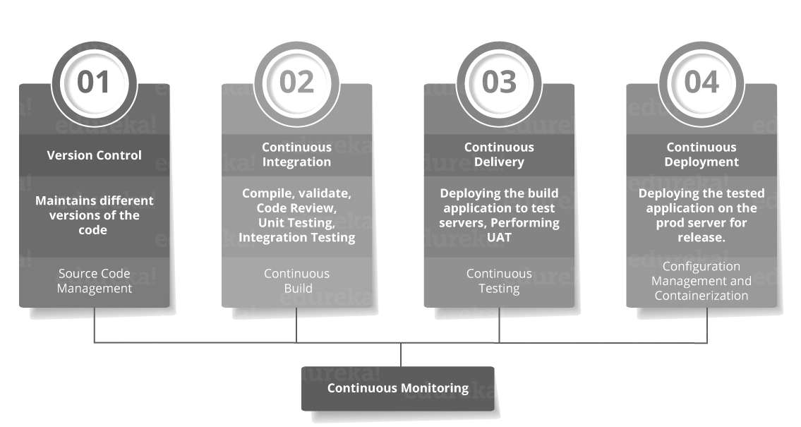This is akin to the Software Development Life Cycle (SDLC)

The pipeline below is a logical demonstration of how software will move along the various stages in this lifecycle before it is delivered to the customer or before it is live in production.

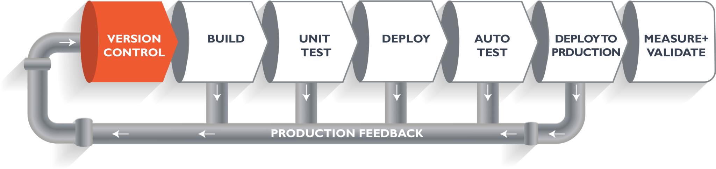

When we build a web application, our developers will commit the code into version control system (such as git, svn), which is the first phase of the pipeline. The code goes to the version control system with a proper version tag.

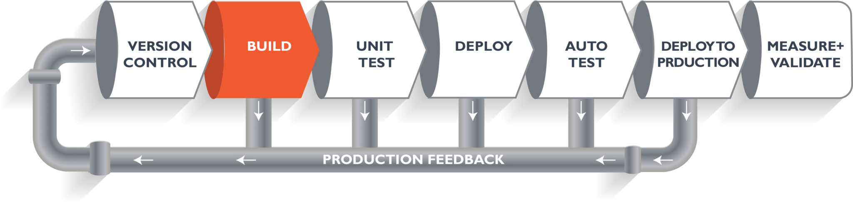Through the version control phase, it again goes to the build phase, where it is compiled with all the features of the code from various branches of the repository. The code is merged and compiled. This whole process comprises the build phase.

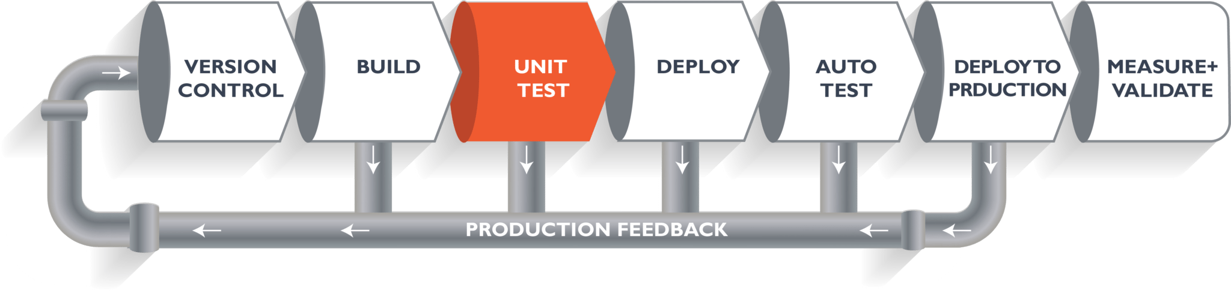Once the build phase is over, the code is moved into the testing phase. In this phase, various kinds of testing is conducted. One of them is the unit test (where a chunk/unit of software is tested for sanity).

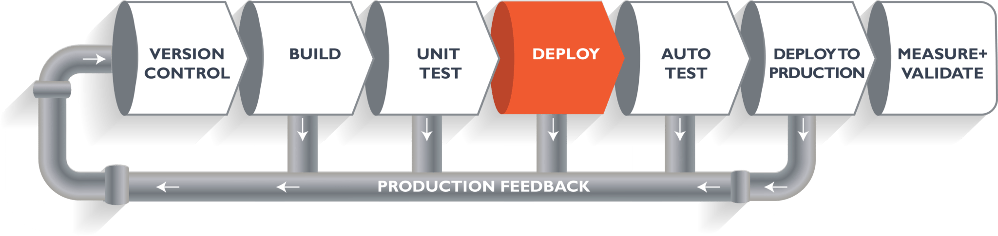When the test is completed, the code is deployed into a staging or a test server. Here, you can view the code or you can view the app in a simulator.

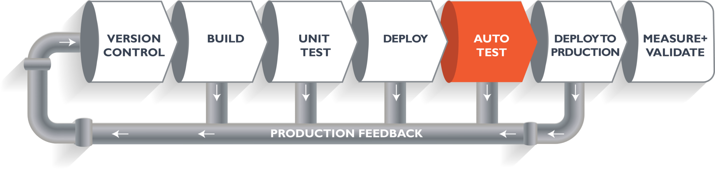

Once the code is deployed successfully, another round of sanity test is conducted. If everything is accepted, then it is deployed to production.

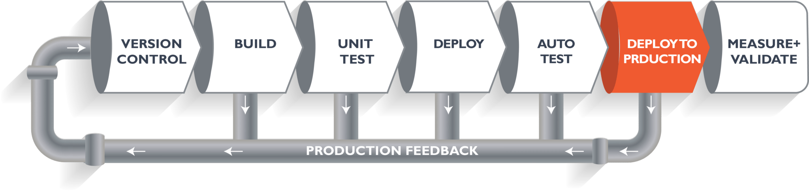Meanwhile, in every step, if there is an error, am email is relayed to the development team so that they can fix it. Then they will push it into the version control system and it goes back into the pipeline.

Once again, if there is any error reported during testing, the feedback goes to the dev team again, where they fix it and the process reiterates if required.

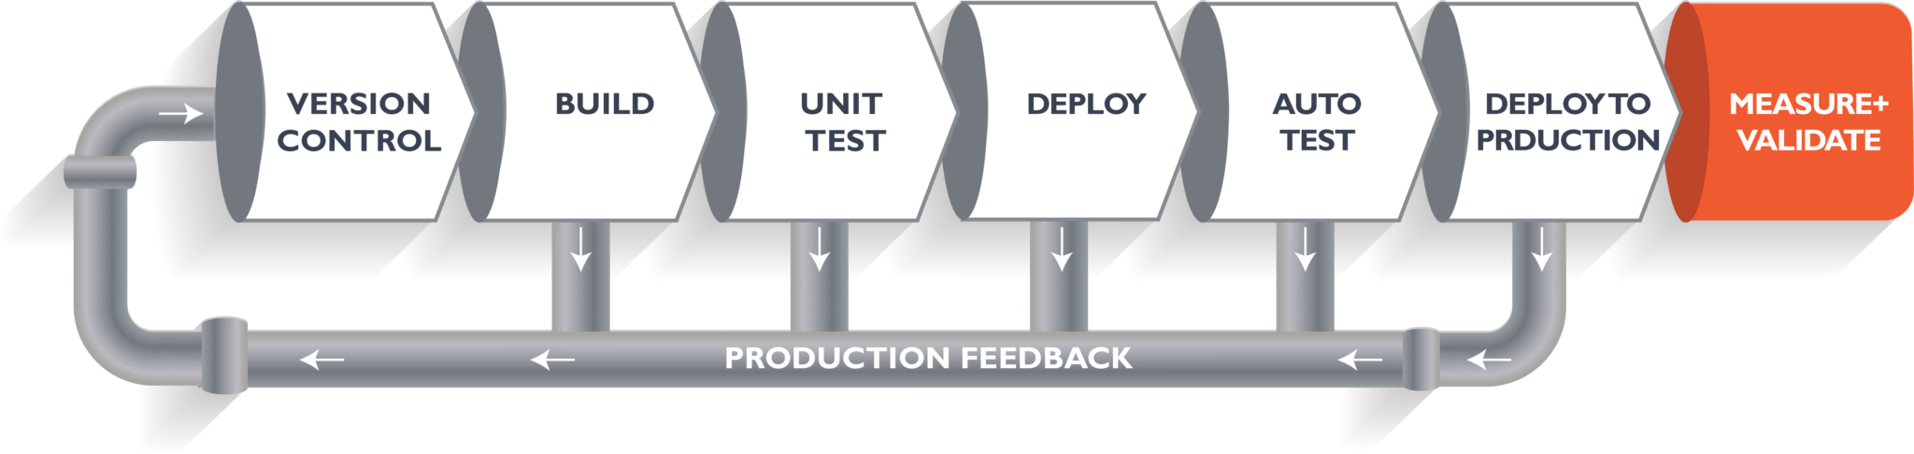This lifecycle continues until the code/a product can be measured and validated.

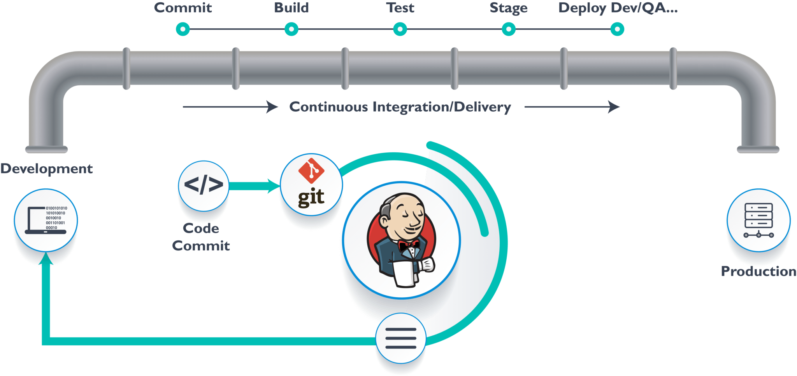To automate the entire process, i.e. from development to production Verbat makes use of automation tools. Verbat makes use of Jenkins which provides various interfaces and tools that automate the entire process.

Git repository is where the development team will commit the code. Jenkins takes over from there. It has a front-end tool that allows you to define the entire job or the task and ensures the continuous integration and delivery process.

From Git, Jenkins pulls the code and then Jenkins moves it into the commit phase, where the code is committed from every branch. The build phase is where code compilation happens. If it is Java code, tools like maven compile the code, which can be deployed to run a series of tests. These test cases are overseen by Jenkins again.

Then, it moves on to the staging server to deploy it using Docker. After a series of unit tests or sanity tests, it moves on to production.

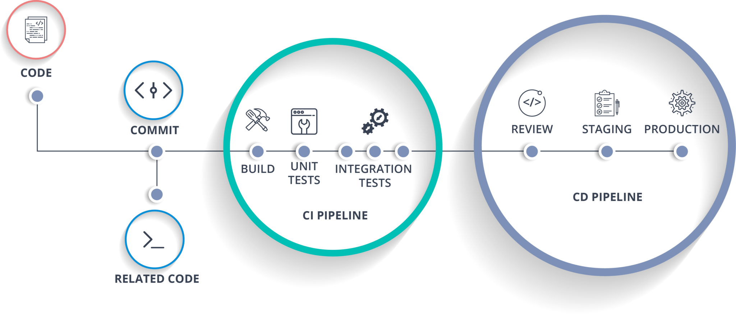

As mentioned before unit testing is one type of testing conducted. Aside from Unit testing, Verbat also makes use of tests based on

### Behavior Driven Development (BDD)

BDD encourages communication between project stakeholders so all members understand each feature, prior to the development process. In BDD, testers, developers, and business analysts create “scenarios”, which facilitate example-focused communication.

The idea of BDD is that the team creates scenarios, builds tests around those scenarios which initially fail, and then builds the software functionality that makes the scenarios pass. It is different from traditional Test Driven Development (TDD) in that complete software functionality is tested, not just individual components.

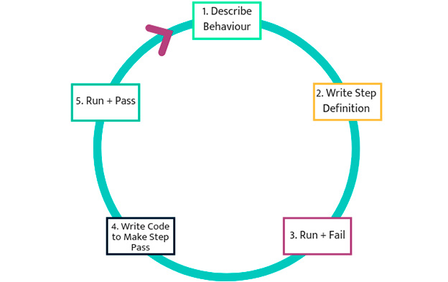

### Acceptance Test Driven Development (ATDD)

ATDD involves the customer, developer, and tester. “Three Amigos” meetings are held to gather input from these three roles, and use them to define acceptance tests. The customer focuses on the problem, the developer pays attention to how the problem will be solved, and the tester looks at what could go wrong.

The acceptance tests represent a user’s perspective, and specify how the system will function. They also ensure that the system functions as intended. Acceptance tests can often be automated. Like in the BDD approach, acceptance tests are written first, they initially fail, and then software functionality is built around the tests until they pass.

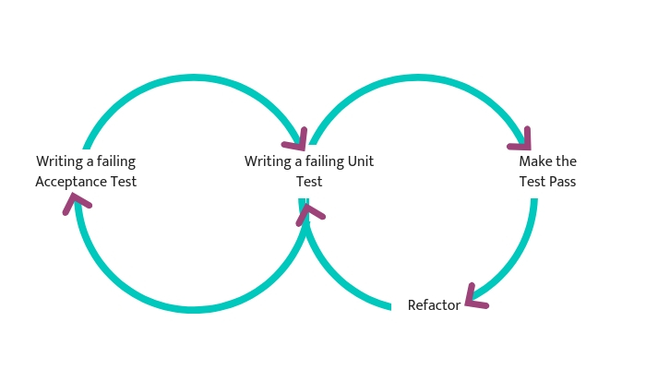

### Exploratory Testing

In exploratory testing, the test execution and the test design phase go together. This type of testing focuses on interacting with working software rather than separately planning, building and running tests.

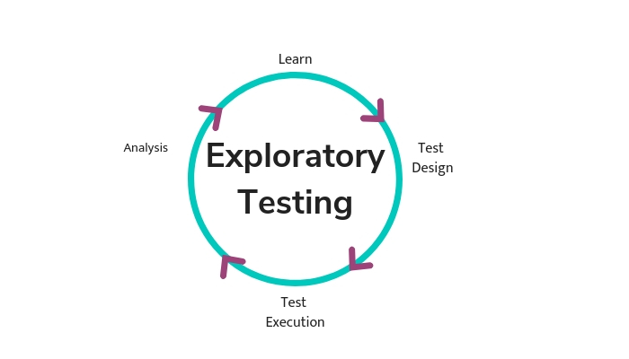Exploratory testing lets testers “play with” the software in a chaotic way. Exploratory testing is not scripted – testers mimic possible user behaviors and get creative, trying to find actions or edge cases that will break the software. Testers do not document the exact process in which they tested the software, but when they find a defect, they document it as usual.

## ON-GOING SUPPORT

* Maintenance contracts by default are supported as per the basic SLA terms.
* AMC with Basic SLA is charged at % of the total project value. Additional Effort/change management request will be added towards Total Value of the Project to determine the AMC value.
* Maintenance support is limited to providing application support for ensuring the consistency of the look-and-feel, bug fixes and user issues i.e. maintenance and support of the existing features of the application.
* Support does not in any way cover providing technical or other support to the end users or hardware support. The maintenance agreement does not include functionality changes or feature additions which are handled as change requests which will be charged per man day rate. AMC does not include server support, maintenance and application deployment.
* AMC charges will cover Off-Site Support and Debugging. Support includes E-mail, telephone and video conference (if required). In the event, the application is hosted with the client or if it is a client server development; necessary remote desktop connectivity should be provided for carrying out maintenance activities.
* All maintenance support will be executed by Verbat off-site team. In the event of any need for on-site work, all expenses incurred for such trips (flights, accommodation, meals transportation) will be payable to Verbat by client.
* Gap in AMC - In case if the client does not opt an AMC for a year and wants to renew it after that period, % of the AMC amount for the year for which AMC is not taken will also be payable if the client wishes to renew the AMC contract.

|  |  |  |  |  |
| --- | --- | --- | --- | --- |
| **SLA Type** | **Max Response Time** | | **Max Resolution Time** | **Target** |
| Basic | 1 working day | 3 working days | | Request / incident / problem tickets |

* *Note:*
* Time zone applicable as per India Time Zones (3:30 GMT to 12:30 GMT, Monday to Friday)
* Please note that the AMC support shall start only after all the necessary sign-offs (AMC Document) to this effect have been given.
* It is not mandatory that the client should opt for an AMC. The client will still be supported on an ad-hoc basis on an agreed man-day rate.
* AMC Payment Terms: 100% to be paid as advance.
* AMC Option: Client can opt for time and material based Annual Maintenance, the details of which will be shared post the completion of project.

## LIST OF DELIVERABLES

* Project Plan
* Software Requirement Specification Document (SRS)
* UI/UX Design
* Functional Specification
* Fully Developed & Tested Application
* Documentations related to System Architecture, Database schema & Database backup
* Source Code

### DELIVERY ACTIVITY SUMMARY

|  |  |
| --- | --- |
| Activities | Description |
| Detailed requirement Analysis | Verbat team to conduct detailed study of requirement for the phase. If clarification is required, team will reach out to Client for more information and/or time for discussions. |
| DB Design | DB design for central and test DB. |
| Software Requirement Specification document (SRS) | Once the requirement analysis is completed, Verbat team will submit the SRS document for approval |
| UI/UX Design, Prototyping | Based on the SRS, Verbat UX/UI team will work on the UI/UX of the screens and submit for approval |
| Functional Specification Document (FS) | Once the UI/UX is approved, Verbat shall submit an FS document for approval. |
| Development | Actual system development starts based on the FS. This involves detailed design and software development of Web Application. |
| Testing | Test Planning, test plan creations, internal, integration testing and user acceptance testing. |
| Deployment | Deploying the latest built in the Verbat Test Server. |

## Detailed Functional Requirements

### Web Development

|  |
| --- |
| **Key website modules** |
| Service Directory (List of services for public, MOJ, Legal community) |
| **Legal Community** |
| Electronic filing |
| Lawyer Registration |
| Translator Registration |
| Trainee Registration |
| Expert Registration |
| ITJS Magazine |
| Registered Users |
| **Public Users** |
| E-notary |
| Lawyer-Law firm search |
| Case Status Search |
| E-calendar |
| Contact Minister |
| E-zawaj |
| Minor Affairs |
| E-refund System |
| **MOJ Users** |
| E-notary |
| CMS |
| E-judge |
| E-legislation |
| E-zawaj system |
| MOJ Dashboard |
| Comparative Legislations |
| Minors |
| **About MOJ** |
| Our Strategy |
| Organizational Structure |
| Employee Gate |
| Careers |
| Legal References |
| Latest Legislation and Laws |
| **E-Participation** |
| Social Media |
| General Survey |
| Opinions |
| Contact Minister |
| Contact Inspection Department |
| Legal in your help |
| Suggestions and complaints |
| Services Guide |
| Services Form |
| Facebook |
| Twitter |
| YouTube |
| Instagram |
| **Open Data** |
| Statistics |
| Policy |
| **Media Center** |
| Events & Future activities |
| Media gallery for images published on portal |
| News |
| Campaign |
| Events |
| Initiatives |
| Media Kit |
| **General** |
| Disclaimer |
| Accessibility |
| Privacy policy |
| Archive |
| Copyright |
| Terms and Conditions |
| Sitemap |
| FAQ |
| Customer happiness formula |
| Glossary |
| Feedback form |
| Contact Us |
| Toll Free |
| Location Map |
| Useful links |
| Print page |
| events calendar |
| Google Analytics |
| Follow TRA Guidelines |
| Responsive web app that scales well on tablets mobile and desktop browsers |
| **Content Management System** |
| Personalized content |
| Unlimited structure (Pages, News, Galleries, Publications etc.) |
| Content editor – Should be able to copy & paste from word |
| User roles with different permissions |
| CMS search facility |
| CMS insight reports(identify non-translated contents and missing items) |
| Image/Document Library: |
| Image with localized Alt text |
| Media gallery for images published on portal |
| Related Items: Associated articles |
| Login/Logout |
|  |
| **Advanced Search** |
| Comprehensive search |
| Keyword search, date filter, Autocomplete & suggestions, contents(pages,  services, news etc. |
| **Other Features** |
| Migrate existing website contents |
| Integrate google auto translate, localize content(UN recommend top 6 languages) |
| META description for all pages to support SEO (Friendly URLS for pages, images etc.) |
| Integrate text to speech add-on |
| Integrate happiness meter supported by PMO Systems |
| Integrate MOJ social media |
| Integrate MOJ Live chat service |
| Surveys & Polls |
| Create & publish unlimited surveys & polls |
| Archive section |
| Cross browser compatibility |
| XML site map |
| Accessibility features |
| font size, night reading, color blindness, text to speech, 3 color themes |
| English & Arabic site |

### Mobile Development

|  |
| --- |
| **Mobile Application features** |
| Informational Pages |
| News |
| Events timeline |
| Advance search |
| Service search with service card |
| Contact us |
| Get directions features |
| Locations across the UAE |
| Accessibility features(minimum 3) |
| Theming options |
| Push Notifications |
| Integration with khadamati and happiness meter |
| English & Arabic |

## TIME SCALE FOR PHASES (WITH ASSUMPTIONS)

Phase 1: Web Development



Phase 2: Services



Phase 3: Mobile Development (Android & IOS) – Parallel to Phase 2



The timeline estimated for delivering the web application will be as below:

* __ Working days to complete the proof of concept on completion of resource mobilization.
* __ Working days to complete the SRS & prototype of Language Translation Application.
* __ Working days to complete the development.

The timeline estimated for delivering the Mobile application will be as below:

* __ Working days to complete the proof of concept on completion of resource mobilization.
* __ Working days to complete the SRS & prototype of Language Translation Application.
* __ Working days to complete the development.

| **Activity** |
| --- |
| Contract Signoff (T0) |
| Proof of Concept-Allocate Resource |
| Proof of Concept-Complete |
| Proof of Concept- Approval (T1) |
| Detailed Requirement Gathering |
| Software Requirement Specification Document (SRS) |
| SRS Approval (T2) |
| System UI/UX Prototype-Complete |
| System UI/UX Prototype-Approval (T3) |
| Functional Specification (FS) |
| FS Approval (T4) |
| Development Phase-Complete |
| Perform QC (Unit Testing and Integration Testing) |
| System ready for UAT |
| UAT Acceptance on Verbat production server (T5) |

*Note:*

* The above-mentioned timeline is in Working Days.
* Upon project confirmation, Verbat requires a lead time of minimum () working days for resource mobilization for proof of concept.
* Resource mobilization will be initiated post the confirmation of the project along with LPO, signed Proposal and advance payment.
* The initiation of the UI/UX/Prototype development is dependent on the confirmation of SRS.
* The above-mentioned timeline for development is post-confirmation of FS.
* Documentation submitted after project initiation and system study supersedes any proposal or documentation submitted during initial requirement gathering / discussion / negotiation.
* Project plan will be submitted post the confirmation of project with necessary payments.
* Any delay in getting the approvals of deliverables from client will cause change in timelines and the revised timelines will be updated in weekly status reports shared with client after the project commencement.
* All approvals and queries regarding the client requirement and any queries which may hinder the project advancement at any stage should be answered by the client within () business days from the time of initiation, failing which, the time delay will get added to the actual effort and timeline estimated.

## ACCEPTANCE CRITERIA

* UAT (User Acceptance Test) sign off should take place within 14 Days from the first release of the application and the acceptance confirmation needs to be mailed to Verbat failing which Verbat will consider the project as approved by the client.
* Any comments and reasons for rejection need to be documented and the same need to be sent as an email from the official mail id of client to Verbat on or before 14 days from the first release.
* Timeframe for acceptance for any further release will be mutually agreed and finalized between client and Verbat depending on the UAT Comments

# MOJ RESOURCE ASSUMPTIONS AND RESPONSIBILITIES

Verbat expects the following resources from the client to be actively involved during the conceptualization and development phases of the project. Verbat shall try to understand the scope and objectives of the project, both from a product and project perspective. However it shall need guidance and leadership from the client to ensure that the project stays on track. Misguided assumptions, incorrect dependencies and constraints can make a project vulnerable to failure at the onset.

|  |  |
| --- | --- |
| Stakeholder | Objective |
| UI / UX | Recommend or Approve UI / UX designs created by Verbat’ designers |
| Project Manager / Owner | Provide necessary guidance in understanding the scope of the project as well |
| Product Owner | Responsible for the prioritized work item list (Product backlog), for making decisions in a timely manner, and for providing information in a timely manner. |
| Technical experts | Responsible for the technical evaluation of the proposed solution |
| Domain Expert | Domain experts to work with the team, to explain the details of a requirement or the sponsoring executive to explain the vision for the project. |
| Independent Tester | Responsible for verification of the final product or the functionality of major modules. This individual shall have clear and concise knowledge of the project being developed. (Verbat shall engage its own QA to verify the product). The client is responsible for UAT and business validation |

# INFRASTRUCTURE DESIGN AND ARCHITECTURE

The proposed application is a web-based system that can be hosted in the cloud or on premise; there is no need for a license, so there is no limit to the number of simultaneous users

* System requires consistent internet connectivity for cloud-based system
* System requires human resources and hardware to support on premise system with offline capability
* There are no limits to the number of users who can use the system at one time
* There are no limits to the number stock locations you can manage
* Can be accessed from mobile devices
* Can be integrated with third-party software systems through REST API

## Deployment Options

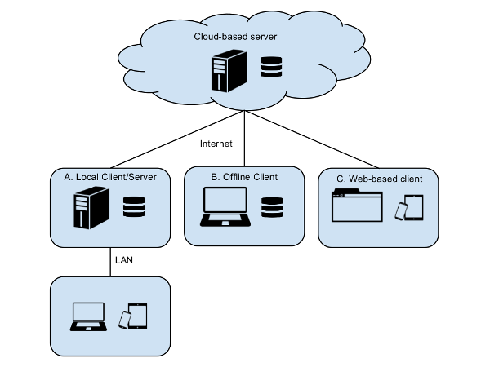

## Technology Architecture

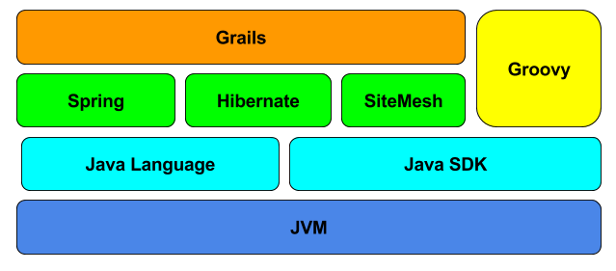

## Server Architecture

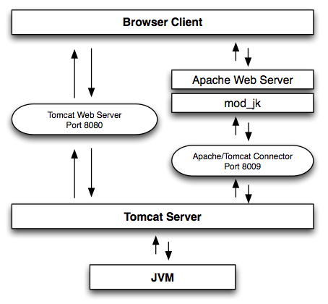

# QUALITY PLAN

Managing quality is not a trivial activity. Verbat has various approaches to managing quality and it depends on the nature of the project. In this case, it relates to the redesign and development of an existing site. Therefore the nature of the discussion shall be tailored to our approach on managing the quality of a user friendly website and mobile app.

Some sane defaults to our approach on quality are

## Communication

The first and foremost step to quality is clear and succinct communication. Our UI /UX team will discuss the usability and functionality of every module with each other as well as with the client. This helps us to gain better clarity on the design. We start out with designs on the white board. This helps us to contemplate and brainstorm new ideas which are eventually translated to mockups using Photoshop. Obviously we engage our clients during the entire design process and our design process never stops unless the designs are ratified by the client.

## Content management

We help our clients to curate content that is fresh, interactive, readable and easily understandable. We do not recommend copy-paste technique’s as it needs to be unique and without blunders. We ensure that the content adheres to the following tenets

* Wise usage of space
* Leave enough white space for the content to breathe
* Avoid irrelevant images
* Avoid poor readability
* Avoid contrasting colors & inappropriate font size
* Avoid Broken links & Validation errors
* Cross Browser compatibility
* The Copyright year should be the year when the website is launched
* Avoid Spelling and grammatical mistakes
* Provide space between words
* Spacing after punctuation is necessary
* Start a sentence with capital letter
* Check if there is any discrepancy in the content
* Unorganized content layout
* Check the caption. Do not place full stops between captions.

## Website Functionality

Our functionality checks include

* Ensure a proper navigation
* Avoid communication errors-Newsletter subscription, Contact information etc.
* Provide a comment section to login or register before the user starts filling the application
* Check if all the links are functional
* Double check site functionalities
* Reduce the Loading Time
* Provision to log in & log out
* Proper Transaction checks
* Identify error in sending mails
* Optimize Images
* Optimize Large Files
* Use Clean CSS

Verbat has identified various risk factors associated with this assignment and understands the impact of these risk factors on the project schedules. The objective of this section is to highlight for both Verbat and client, the risk factors, to analyze the impact of the risks on project execution, and to propose strategies to control and reduce the impact of the risk factor. These various risks, which could arise during the project, are tabulated below along with mitigation implementation.

| Type of risk | Impact | Risk Mitigation | Risk Handling |
| --- | --- | --- | --- |
| Scope Creep | H | Functions and features will be detailed in system requirement documents and will go through client approval. Once this document is approved, any change to requirement will go through change management review for possible impact assessment. | Proper change management procedure will be implemented. |
| Delay in customer feedback | H | The plan is prepared with enough lead-time for customer reviews and approvals.  The customer is indicated with the dates when the document is expected after review and approval. | The request for feedback will be escalated if not attended at the right time so that the schedules are not affected. Deemed acceptance criterion is set up front and will be followed. |
| Non-availability of necessary software’s, frameworks, database instances and infrastructure at client’s hosting environment(If hosting support is provided by Verbat ) | M | Client will be informed in advance on these requirements. | Possible impact to schedule. |
| Manpower attrition | L | All efforts would be made to ensure process dependence rather than being person dependent. As a risk mitigation plan Verbat will train backups. | A new person will be identified as early as possible, provided the required project-specific training and mentored by the senior members of the team to minimise impact of attrition on the project. |

*H-High, M-Medium, L-Low, NA-Not Applicable*

# WARRANTY OF SOLUTION

* Verbat shall provide a bug ﬁx warranty at no additional cost for 30 days from the date of acceptance of the project, for correction of any errors in the developed application that may be attributed to Verbat.
* However, this does not cover modifications by Client, or use of the application on an environment other than the proposed environment, or other circumstances outside Verbat’s reasonable control. In such a case Verbat reserves the right to charge for its services.
* All error corrections will be executed by Verbat offsite team. In the event of any need for on-site work, all expenses incurred for such trips (flights, accommodation, meals, transportation) will be payable to Verbat by Client.

# FACILITIES REQUIREMENT

Verbat has offices in India and Dubai. We do not require an office space to implement the project

# NAMED RESOURCES FROM VENDOR

|  |  |
| --- | --- |
| Resource |  |
| Project Manager User Interface | **Application Architect** |
| Scrum Master | **Database Architect** |
| Business Analyst | **User Experience** |
| Technical Documenter | **User Interface** |
| Senior Developer | **QA Lead** |
| Junior Developer | **QA** |
| Team Lead |  |

# PROJECT MANAGEMENT METHODOLOGY

### PROJECT MANAGEMENT

The Verbat development center strictly follows industry standards on quality. The project management is process governed by the Verbat Quality Management system and is put to verification through internal audit programs that happen from time to time. Verbat will dedicate a project manager for the proposed implementation. Verbat proposes Client to identify one project manager who will be driving activities to be undertaken by Client to be the single point of contact for Verbat.

### PROPOSED SOLUTION MODEL

**STAND- ALONE FIXED BID**

Verbat will be following a stand–alone fixed bid solution delivery model wherein the required solution would be devised and a suitable pricing would be offered. Verbat’s solution architects have conducted a thorough research on the requirements and have come to the conclusion that our proposed solution, which is detailed further in this document, will meet the requirements put forth by the client.

**KEY STRENGTHS OF OUR SOLUTION**

* Strong and Scalable platform accommodating to future enhancements
* A framework which acts as a solution accelerator with building blocks that can be re-used in future for building new components and features.
* Our light weight framework used consumes fewer system resources thereby making the application perform faster.
* All security aspects are considered

### PROJECT IMPLEMENTATION PLAN

Verbat will be providing the solution in a stand-alone fixed bid approach which ensures minimum viable solution for quick wins with core focus on the long-term business objective and outcome. Once the implementation is over, Verbat will initiate the application maintenance process (once the maintenance contract is signed) which continues to extend after the implementation.

# FINANCIALS

## COSTS

### PROFESSIONAL SERVICES COST

### LICENSE COST

### TRAINING

### YEARLY MAINTENANCE COST

### SUPPORT MODEL POST GO LIVE

### HOURLY/DAILY RATES FOR ADDITIONAL DEVELOPMENT/WEBSITE MANAGEMENT

## PAYMENT MILESTONES

### PAYMENT TERMS

* 30% () of total project value to be paid as advance along with the Purchase Order
* 40% () of total project value to be paid on confirmation of the UI/UX
* 30% () of the total project value to be paid on completion of Development and UAT on Verbat test server
* 100% advance payment along with Purchase Order to initiate Server purchase

*Note:*

Payment should be made *within 7 days from the date of invoice.*

# VENDOR PROFILE

|  |  |
| --- | --- |
| **Company Name** |  |
| **Contact Number** |  |
| **Contact E-mail** |  |

**COMPANY BACKGROUND AND EXPERIENCE**

|  |  |  |  |
| --- | --- | --- | --- |
|  | **Question** | **Answer** | |
| 1 | Years of Experience |  | |
| 2 | Office Locations |  | |
| 3 | Developers Location |  | |
| 4 | Designers Location |  | |
| 5 | Company Address |  | |
| 6 | How many developers are employed? |  | |
| 7 | How many designers are employed? |  | |
| 8 | How many account managers are employed? |  | |
| 9 | Are you aware of the TRA website guidelines? |  | |
| 10 | Have you worked with UAE governmental federal entities? |  | |
| 11 | If your answer is yes , please list down the governmental entities names and their TRA rank percentage: | Name | Rank achieved % |
|  |  |
| 12 | Have you done user experience exercise before , if yes please name the entities |  | |
| 13 | Do you have experience with TRA SSO? If answer yes, please name the projects |  | |
| 14 | Do you have experience with E-Dirham integration? If answer yes, please name the projects |  | |
| 15 | Do you have experience with third party system integration? If answer yes, please name two projects |  | |
| 16 | Do you have experience with Q-system integration? If answer yes, please name the projects |  | |
| 17 | Do you have experience with TRA integration (E-consultation, khadamati, open data?) If answer is yes, please provide the names |  | |
| 18 | Do you provide the source code of the project as a part of the main deliverables without any extra charges? |  | |
| 19 | Have your company developed federal government mobile apps? If yes please list the names |  | |
| 20 | Can you please specify the rank of your mobile experience with the federal government apps? |  | |
| 21 | Have your company had the experience with mobile app SSO integration? |  | |
| 22 | Have your team developed API’s for mobile integrations? |  | |
| 23 | Do you have mobile apps native development experience? |  | |
| 24 | Do you have in-house systems/web/apps testing lab? |  | |

# NON-FUNCTIONAL REQUIREMENT (OTHERS)

|  |  |
| --- | --- |
| **Requirements** | **Details** |
| User Experience and  UI Design | * The application will be developed only in English and Arabic * The layout and graphical components will be created considering the usability factors |
| Performance | * Application will allow users to have smooth and quick access to the information or services they require. |
| Security | * Web security standards will be followed. |

**MS SQL2012  
Windows 8/10  
Web Services**

HTML5 / CSS3

Java Script

ASP.Net, MVC

, Android SDK

Windows

IIS

MS SQL

Android

# OUT OF SCOPE.

With the ever evolving digital market, the requirement should be clear to both the parties involved, hence the importance of mentioning the out of scope details of the project. Following are considered to be out of scope while creating this proposal:

* Purchase of images, fonts
* Any language other than English & Arabic
* Content or image procurement or uploading or editing
* Audit Trail
* End user testing and load testing
* Developer account creation and Maintenance (Play Store)
* Adding new features to the application other than mentioned in the functional specifications. Such requests will be handled via change management. *For Change management details, please refer section titled “Change Management” in the Proposal*. (refer to section 4.1)
* Annual Maintenance Contract (Bug fixing, debugging, enhancements) – Please refer section titled “Maintenance and Support”, unless contracted for.(refer to section 4.2)
* Hosting Infrastructure and Maintenance (web and email hosting), unless contracted for.
* Application Deployment on the server and respective stores, unless contracted for.
* Backup solution and Disaster recovery unless contracted for.
* Physical deployment onsite / installation of the application in devices and Physical connection, installation of system.
* Integration with third-party, if any, other than mentioned in the functional specifications
* Hardware Integrations / procurement and purchase
* Procurement of SMS gateway / payment gateway / email gateway
* Integration of SMS gateway / payment gateway
* SSL Purchase and installation, if any
* Plugin/template purchases, if any
* OS other than mentioned in the Hardware Interface
* Relevant / related software libraries
* Mobile offline access or operations

## CHANGE MANAGEMENT

Any addition which comes out of the project scope, upon and after the launch of the application will be considered as change management. Verbat recommends the following change management procedure for the same.

* Any change which comes out of the project scope, which was discussed, documented, and mutually approved by both the parties in the requirement stage, will be carried out only through raising a change request.
* Change request will be studied and an impact analysis on the existing work flow will be performed.
* On finalizing the impact, effort estimation for the change will be calculated and raised as additional requirement.
* Verbat will initiate the change request only after getting a formal approval from the client for the additional changes raised.
* 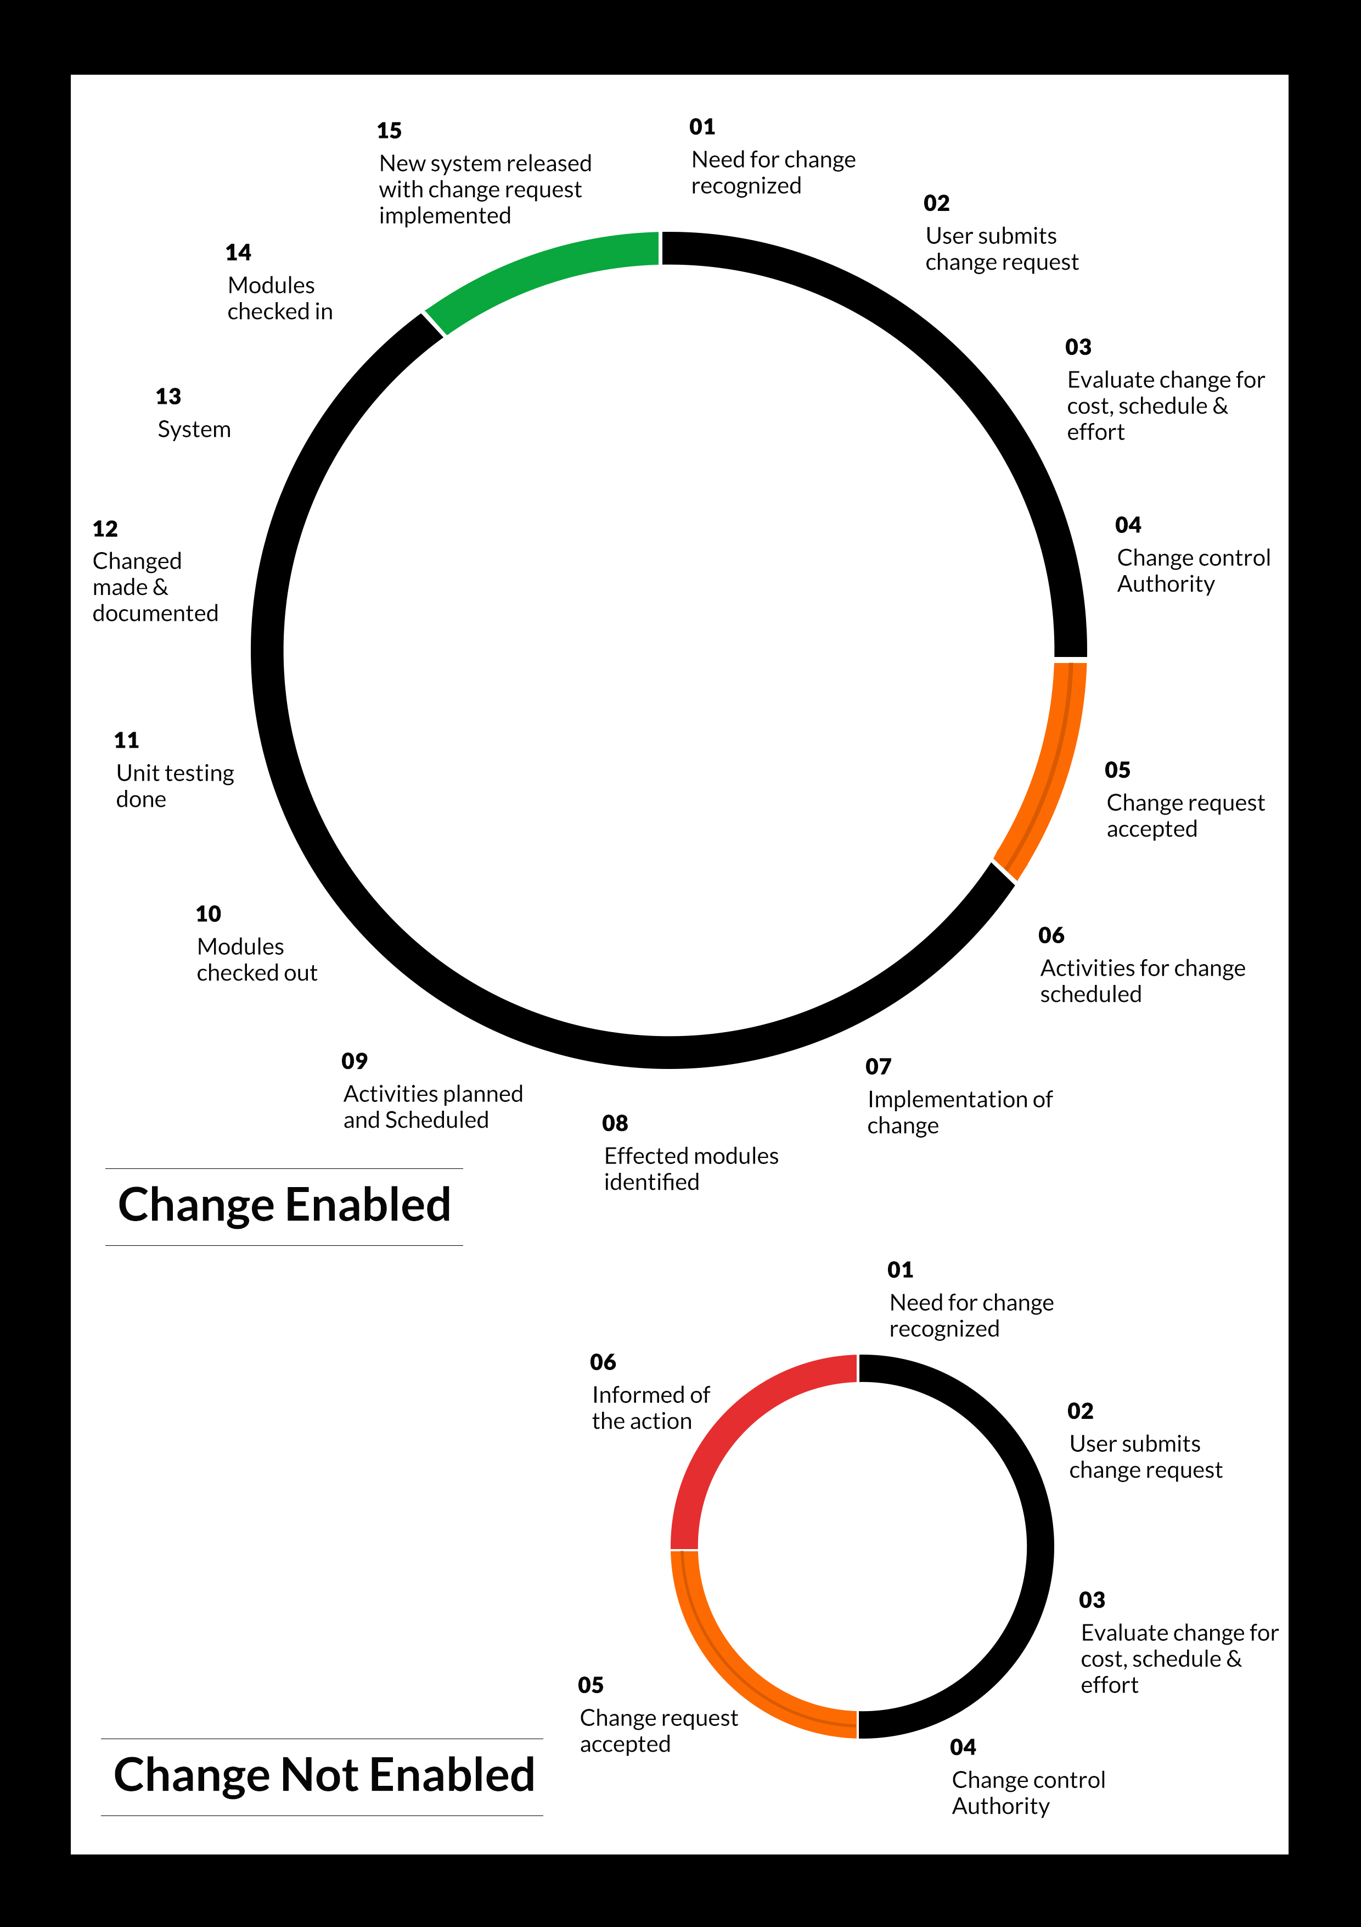Any change from the scope will be charged at AED 1,200.00 per man day effort and approval from the clients will be availed before commencing on any change management.

## MAINTENANCE & SUPPORT

* Maintenance contracts by default are supported as per the basic SLA terms.
* AMC with Basic SLA is charged at 25 % of the total project value. Additional Effort/change management request will be added towards Total Value of the Project to determine the AMC value.
* Maintenance support is limited to providing application support for ensuring the consistency of the look-and-feel, bug fixes and user issues i.e. maintenance and support of the existing features of the application.
* Support does not in any way cover providing technical or other support to the end users. The maintenance agreement does not include functionality changes or feature additions which are handled as change requests which will be charged AED 1,200.00 per man day. AMC does not include server support, maintenance and application deployment.
* AMC charges will cover Off-Site Support and Debugging. Support includes E-mail, Telephone and Chat unless explicitly specified. In the event, the application is hosted with the client; necessary remote desktop connectivity should beprovided for carrying out maintenance activity.
* Gap in AMC - In case if the client does not opt an AMC for a year and want to renew it after that period, 50% of the AMC amount for the year for which AMC is not taken will also be payable if the client wishes to renew the AMC contract.

*Note:*

* *Please note that the AMC support shall start only after all the necessary sign-offs (AMC Document) to this effect have been given.*
* *It is not mandatory that the client should opt for an AMC (replace with perhaps: It is mandatory that the client opts for an AMC). The client will still be supported on an ad-hoc basis on an agreed man-day rate.*
* *AMC Payment Terms: 100% to be paid as advance.*

## SERVICE LEVEL AGREEMENT (SLA)

|  |  |  |  |  |
| --- | --- | --- | --- | --- |
| **SLA Type** | **Max Response Time** | | **Max Resolution Time** | **Target** |
| Basic | 1  working day | 3 working days | | Request / incident / problem tickets |
| Advanced | 5 Business Hours | 12 Business Hours | | Request / incident / problem tickets |
| Priority | 3 Business Hours | 5 Business Hours | | Request / incident / problem tickets |

*Note:*

* *We provide Basic SLA as standard with AMC while Advanced and Priority SLAs attract additional charges.*
* *Time zone applicable (8:00 am to 5.00 pm, Sunday to Thursday)*

AMC Option:

Client can opt for time and material based Annual Maintenance, the details of which will be shared post the completion of project.

# TERMS & CONDITIONS.

## WARRANTY

* Verbat shall provide a bug ﬁx warranty at no additional cost for 30 days from the date of acceptance of the project, for correction of any errors in the developed application that may be attributed to Verbat.
* However, this does not cover modifications by Client, or use of the application on an environment other than the proposed environment, or other circumstances outside Verbat’s reasonable control. In such a case Verbat reserves the right to charge for its services.
* All error corrections will be executed at Verbat India office. In the event of any need for on-site work, all expenses incurred for such trips will be payable to Verbat by Client.

## SOURCE CODE & INTELLECTUAL PROPERTY RIGHTS

* Upon completion of the Project and 100% completion of the payment, client will have access to the source code except for propriety codes, developer tools and third party applications etc.
* The solution offered will be the intellectual property of the client and will be made available to the client on an “unlimited license” basis.
* Modifications by third party/person: No person or organization, other than Verbat or any person authorized by Verbat in writing, has any permission to modify/change the software Solution to be eligible to get continued support from Verbat as per the support terms defined under this document.
* Liabilities/Damages: Verbat accepts no liability or damages of any kind arising out of use or non-use of the software delivered. The responsibility of testing of software lies with Client.

## GENERAL TERMS AND CONDITIONS

* Offer Valid for 30 calendar days from the date of submission of the Proposal.
* An average of 20 working days are assumed in a month.
* All the projects activities will be carried out from our off-shore development center in India
* All the documentation will be provided in English.
* Third party components may be used to develop this application.
* The scope of the project is to develop the Application as detailed in the scope of the project and mentioned in this proposal. Any changes or additions will have to go through change management.
* This proposal would have been derived or concluded from either the RFQ /RFP/data shared via email / information transferred during an initial requirement analysis meeting / tele-conversation. Verbat reserves the right to change the terms of this proposal as the final terms (including the costing), features & functionalities and timeline could change during the course of the project. Hence any fees quoted / timeline committed in this proposal may not be considered as final unless agreed and signed by both parties.
* Web Application will be best viewed only in the environment mentioned in the section Browser Compatibility
* Mobile app will be best viewed only in the environment mentioned in the section Hardware Interface
* All Source Codes and other project artefacts would adhere to the Verbat document templates and internal coding standards.
* The documents delivered to the client includes the ones mentioned under ‘Deliverables’ and these will adhere to Verbat’s internal document standards.
* Acceptance criteria shall be based on the clauses which were mutually discussed between Verbat and client at the Requirement Analysis phase and the same will be documented and approved by both parties through official emails
* In case Client requires any extension of the proposed acceptance schedule, the associated effort and cost of such extension can be mutually reviewed.
* For any circumstances if project needs to be put on Hold / Stop it requires minimum request notice period of 1 week along with duration for which request will be addressed by management and final decision on the request will be based on that
* If deployment is done in client’s server, Verbat cannot be held responsible for any performance issues arising due to hardware malfunctions.
* Client is responsible for data backup in case the application is not hosted on Verbat server.
* Source code will only be delivered or uploaded on the Production Server once the due payments are made.

## GENERAL ADMINISTRATIVE, TECHNICAL & FUNCTIONAL ASSUMPTIONS

* Detailed system study is required before the start of the project.
* During the requirement gathering phase, authorized personnel from the Client’s side is expected to be available for discussion and finalizing the HLD (High Level Design), before development commences.
* Type of reports and formats, if under the scope of the project, needs to be specified by Client before project sign off.
* Workflows if under the scope of the project, need to be specified/ confirmed by client before project signoff.
* Verbat assumes that all sign-offs from Client will be provided within agreed and specified timeframe.
* Client will provide all the necessary contents, both text and image, before starting the project in the format suggested by Verbat (if any).
* The client should provide the relevant information and data well in time for the execution of a related activity. Non- availability of this information or data may lead to an interruption of work which may result in a delay in delivery as well as additional costs to the client.
* Client should have/possess server with technical specifications as suggested by Verbat for the proposed application.
* Client will be provided with one time training (train the trainer) on how to use the application via video conference (maximum of 4 hours). Additional training requests will be charged.

# ABOUT US.

1. Education
2. Transportation

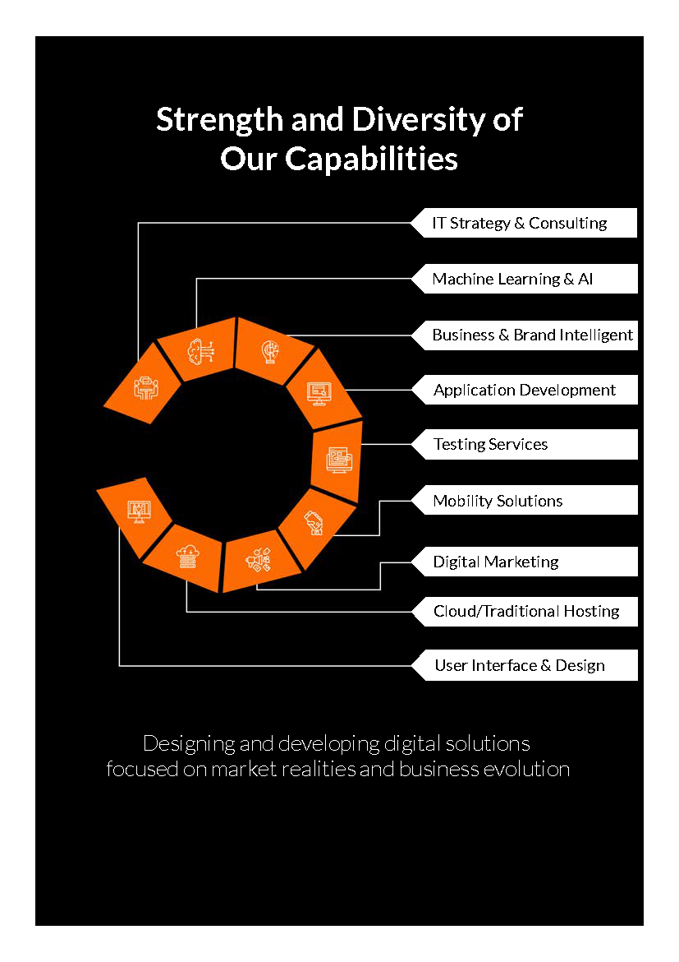



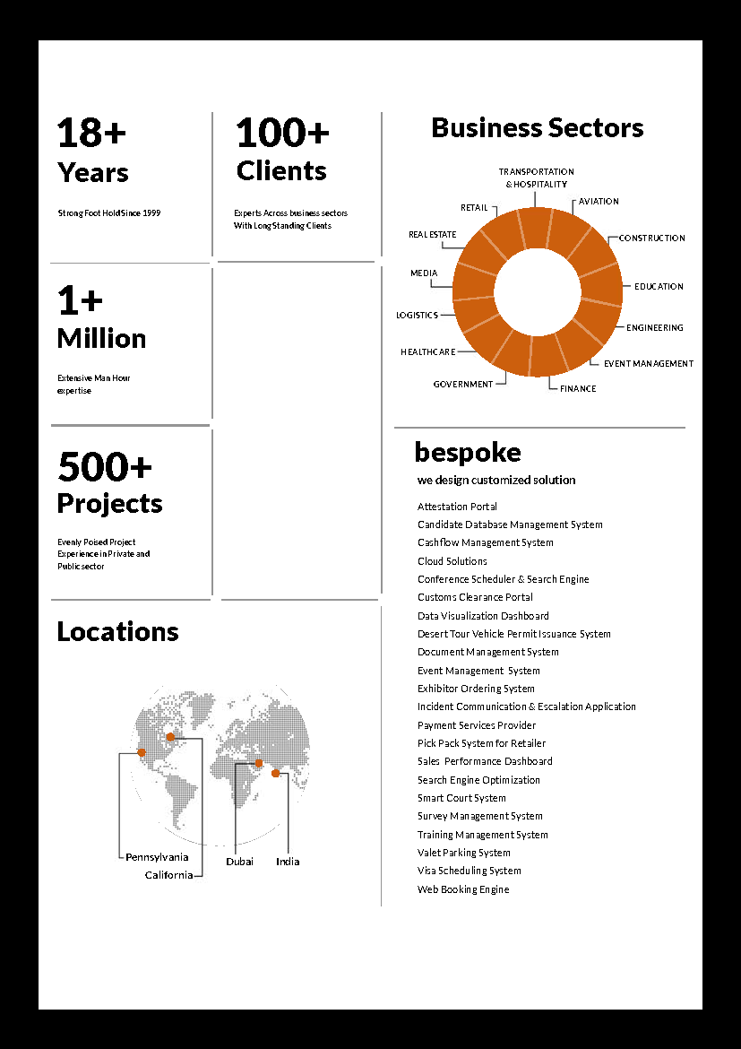

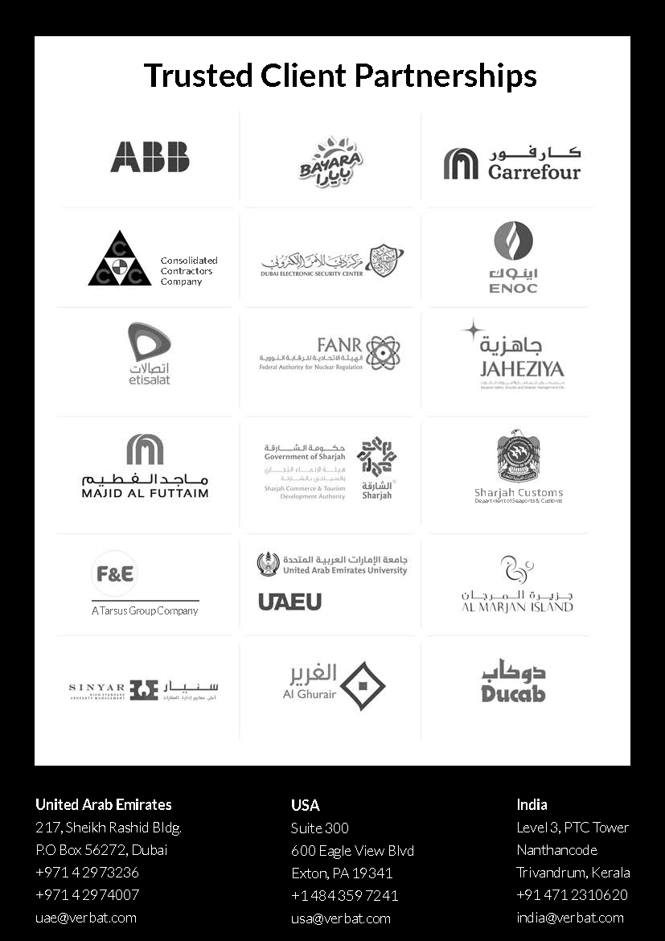

**Conﬁdentiality Notice:**

**This Proposal is conﬁdential and contains proprietary information and intellectual property of Verbanet Technologies LLC. Neither this proposal nor any of the information contained herein may be reproduced or disclosed under any circumstances without the express written permission of Verbanet Technologies L.L.C (hereby known under its brand name of Verbat in the United Arab Emirates). 2018. All rights Reserved**